SUBJECT PRONOUNS | OBJECT PRONOUNS | POSSESSIVE ADJECTIVES | POSSESSIVE PRONOUNS
I | ME | MY | MINE
YOU | YOU | YOUR | YOURS
HE | HIM | HIS | HIS
SHE | HER | HER | HERS
IT | IT | ITS | -
WE | US | OUR | OURS
THEY | THEM | THEIR | THEIRS

- SUBEJCT PRONOUNS ARE FOLLOWED BY A VERB. WE ARE AT HOME. / THEY LIVED IN LONDON.

- OBJECT PRONOUNS GO AFTER A VERB. SANDRA BOUGHT HER A PRESENT.

- POSSESSIVE ADJECTIVES GO BEFORE A NOUN. THEY ARE USED TO SHOW POSSESSION.
MY AUNT WENT TO BRAZIL. OUR TEACHER IS FROM CANADA.

- POSSESSIVE PRONOUNS ARE USED TO INDICATE POSSESSION. THEY ARE NOT FOLLOWED BY A NOUN.
WHOSE THAT BIKE? IT’S HIS.
IS THAT YOUR CAR? NO, MINE IS BLUE.

SUBJECT PRONOUN AND POSSESSIVE ADJECTIVES
- Choose the correct pronoun or possessive:

1) I really like ___ jacket. you your
2) We are finished with ___ work. our we
3) The cat is sleeping in ___ basket. its it
4) They sang ___ teacher a song. their they
5) Give it to ___boss. he his
6) I can't remember what ___ told me. they them
7) I was talking to ___brother about you. her she
8) Have you finished reading ___ book yet? your you
9) Do you think ___ can open this bottle? my I
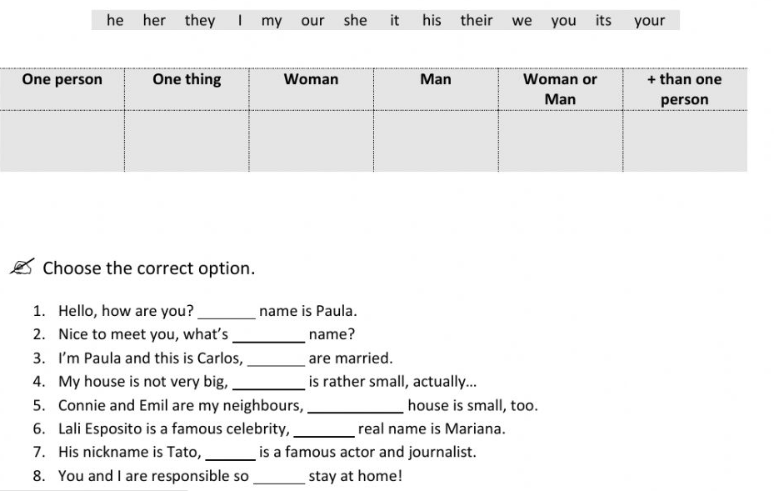
- Put the words in the correct column.

OBJECT PRONOUNS
- Write the correct word in the boxes below.
1. I see ………….…. (they, them) every day .
2. He sits near ………….…… (I, me) in class.
3. She goes with ………….….. (we, us) to the movies a lot.
4. I like………….……. (she, her) very much.
5. I know ……….……… (he, him) and his brother.
6. I often go with .……………... (they, them) to the city.
7. He often helps ……………. (I, me) with my lessons.
8. She writes many letters to ……………….. (he, him).
9. Mr Adams teaches…………………. (we, us) English.
10. He gives many presents to …………….. (she, her).

- Complete the sentences with a SUBJECT PRONOUN or an OBJECT PRONOUN
- Egbert is not English; ............... is Australian.
- Help ............... to prepare for my exam please.
- Albert says he knows ..............., because he met ............... at your party last week.
- Dominic and Kaye are in love; ............... are going to get married.
- This is Lyn's first job and ............... is very nervous.

POSSESSIVE PRONOUNS – POSSESSIVE ADJECTIVES
- Fill in the blanks with the correct possessive adjective or pronoun.

1. Is this _________________ book? (your/yours)
2. Give Maria ____________________ umbrella. (her/hers)
3. No, it's not your turn to answer, it's ____________________. (our/ours)
4. No, that's not ___________________ car. _________ is a convertible. (my/mine)
5. Excuse me. Is this _______________________ classroom. (our/ours)
6. The cat is cold. ____________ fur is wet. (his/hers/its)
7. We didn't bring any drinks to the party. Can we drink ________________ ? (your/yours)
8. Jim brought ______________ coat. But he is hot and doesn't need it. You can use __________ . (his/his)

